**Coding Academy By Orange**

**Elegant Design website**

**By**

**Haneen Tanashat**

**Table of Contents**

|  |  |
| --- | --- |
| Title | Page |
| acknowledgement | **I** |
| Abstract | **II** |
| Chapter One:Introduction and Background | **1** |
| 1.1 Technologies and tools | 2 |
| 1.2 Objective | 3 |
| 1.3 Steganography and Watermarking | 6 |
| 1.4 Steganography Principles | 7 |
| 1.5 Steganography Techniques | 8 |
| 1.6 Research Methodology | 12 |
| 1.7 Problem statements | 12 |
| Chapter Two: Images Overview | **13** |
| 2. Introduction to Images | 14 |
| 2.1. Type of Image | 14 |
| 2.2 Vector Image | 17 |
| 2.3 Raster Image | 17 |
| 2.3.1 Basic Anatomy of Raster Image | 17 |
| 2.3.2 Raster Image File Formats | 18 |
| 2.4 Differences between raster& vector image | 19 |
| Chapter Three: Caesar Cipher | **20** |
| 3.1 Introduction | 21 |
| 3.2 Advantages and disadvantages | 21 |
| 3.3 The algorithm | 22 |
| Chapter Four: System Design and Methodology | **25** |
| 4. Methodology | 26 |
| 4.1. Hidden process | 26 |
| 4.1.1 Image Conversion Unit | 27 |
| 4.1.2 Decision Making Unit | 27 |
| 4.1.3 Hidden Data Unit | 28 |
| 4.1.3.1 Byte Encryption Unit | 29 |
| 4.1.3.2 Byte Splitting Unit | 30 |
| 4.1.3.2 Location Computation Unit | 31 |
| 4.1.3.2 Pixel Combination Unit | 31 |
| 4.2 Extraction Process | 33 |
| 4.2.1 Decision Making Unit | 33 |
| 4.2.2 Extraction Data Unit | 34 |
| 4.2.2.1 Byte Decryption Unit | 34 |
| 4.2.2.2 Extraction Byte from Pixel Unit | 36 |
| 4.3 LCG | 37 |

**Acknowledgement**

‏First and foremost , we thank Allah who enabled us and gave us the courage to achieve this work. After that, we would like to thank our supervisors, MR. Mohammed Frehat, coach Hala Obiedat,coach Alaa Qaza and coach Hala Hamdan for their  assistance, support, guidance and wide knowledge throughout our project. I would like to express our profound gratitude to the members of the Committee for spending their valuable time reading our draft. Finally, we would like to thank our family for their support and assistance throughout our study, as this work would not be done without them.

**Abstract**

**Chapter One**

**Introduction and Background**

* 1. **Technologies and tools**
* **Front-end( HTML, CSS, Bootstrap ,Java Script):**

front end development is that the tools and techniques used to create the front end of a website change constantly and so the developer needs to constantly be aware of how the field is developing.

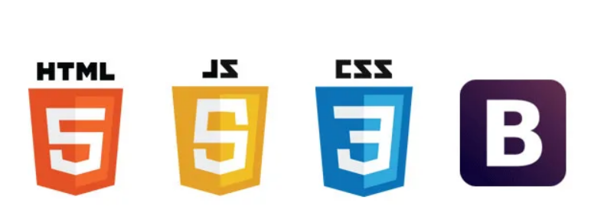

* **Back-end**

* **PHP (Laravel framework):**

Laravel is primarily used for building custom web apps using PHP. It’s a web framework that handles many things that are annoying to build yourself, such as routing, templating HTML, and authentication. Laravel is entirely server-side, due to running on PHP, and focuses heavily on data manipulation and sticking to a Model-View-Controller design.



* **PHP my admin (MySQL):**

MySQL is an open source SQL relational database management system that’s developed and supported by Oracle. MySQL is just one popular system that can store and manage that data for you.



* **Tools:**
* **VS code :**

Visual Studio Code is a code editor in layman’s terms. Visual Studio Code is “a free-editor that helps the programmer write code, helps in debugging and corrects the code using the intelli sense method”. In normal terms, it facilitates users to write the code in an easy manner.



* **XAMPP control panel**:
* is simply a local host or server.
* This local server runs on your personal computer, whether it’s a desktop or a laptop.
* It is used to test clients or websites before publishing them to a remote web server.
* **Figma:**

To draw the wireframe and mockup.



* **Trello:**

a collaboration tool that organizes your projects into boards.

